**Module-2 : EC2 Assignment – 1**

1. **First I’ve created an instance in N.Virginia region with an Ubuntu OS**

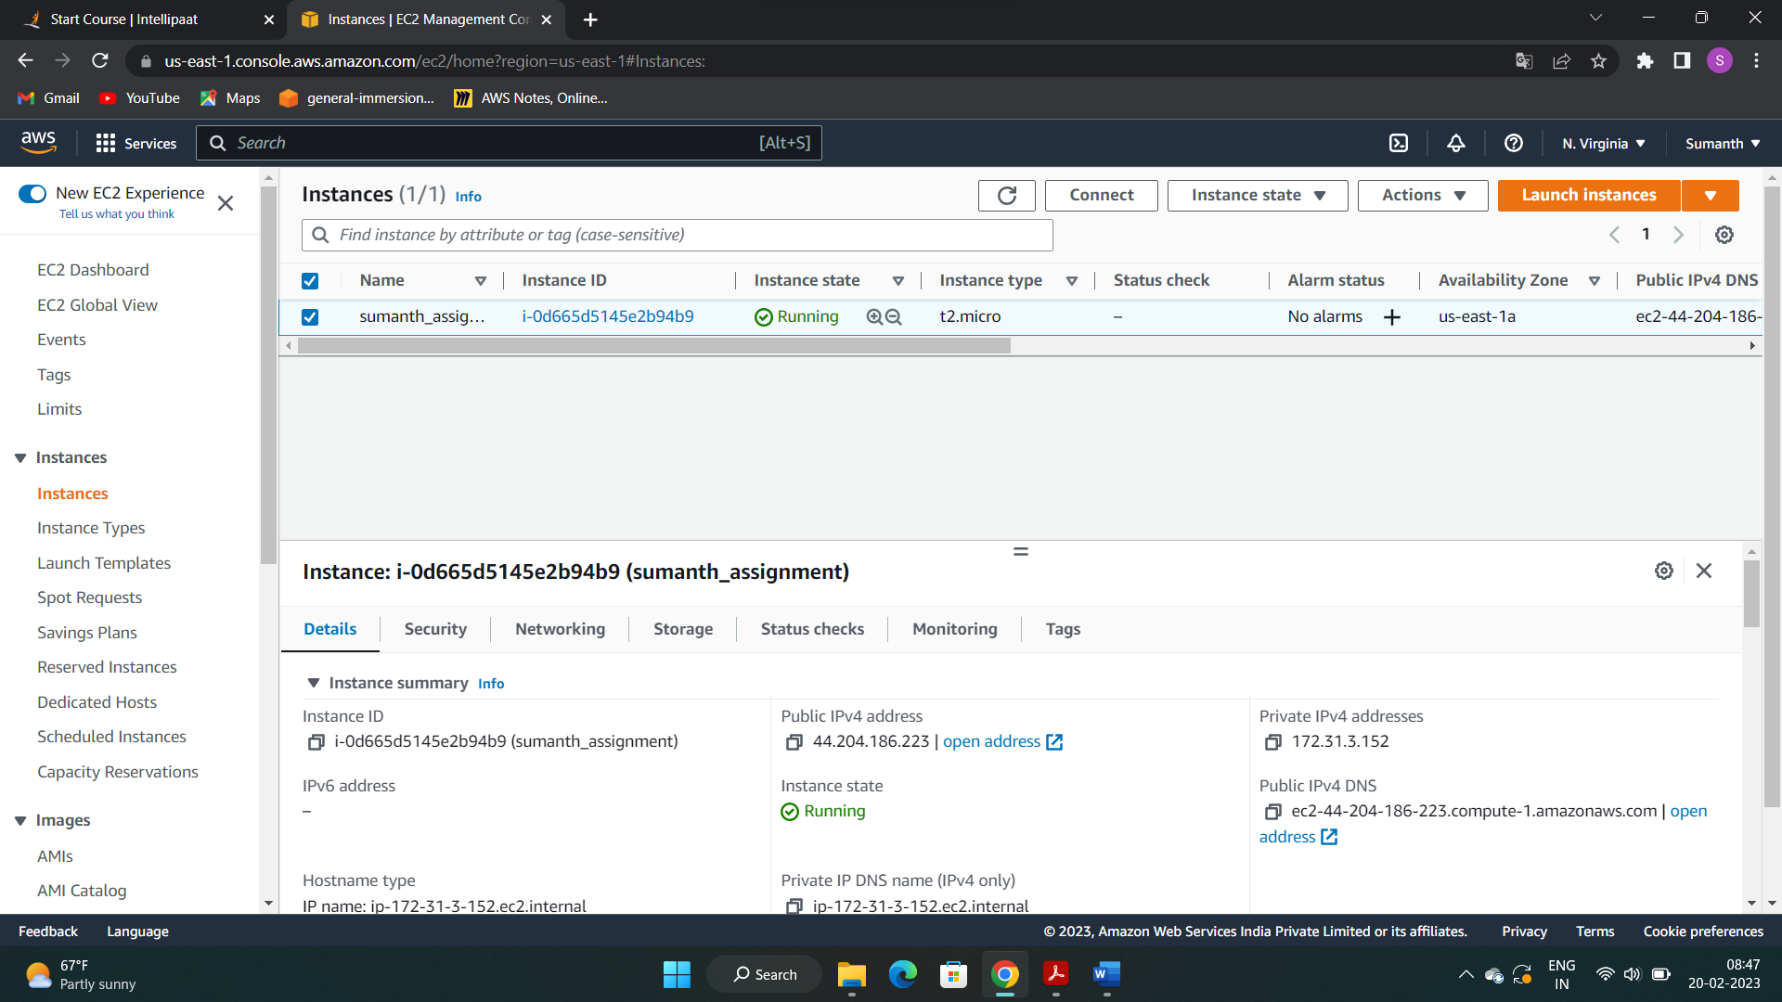

1. **Connected to the instance**

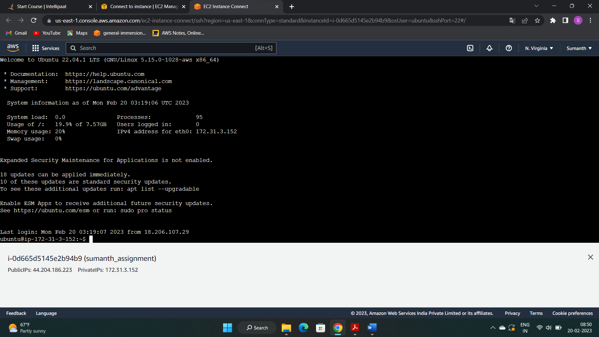

1. **Installed Nginx for making them webservers**

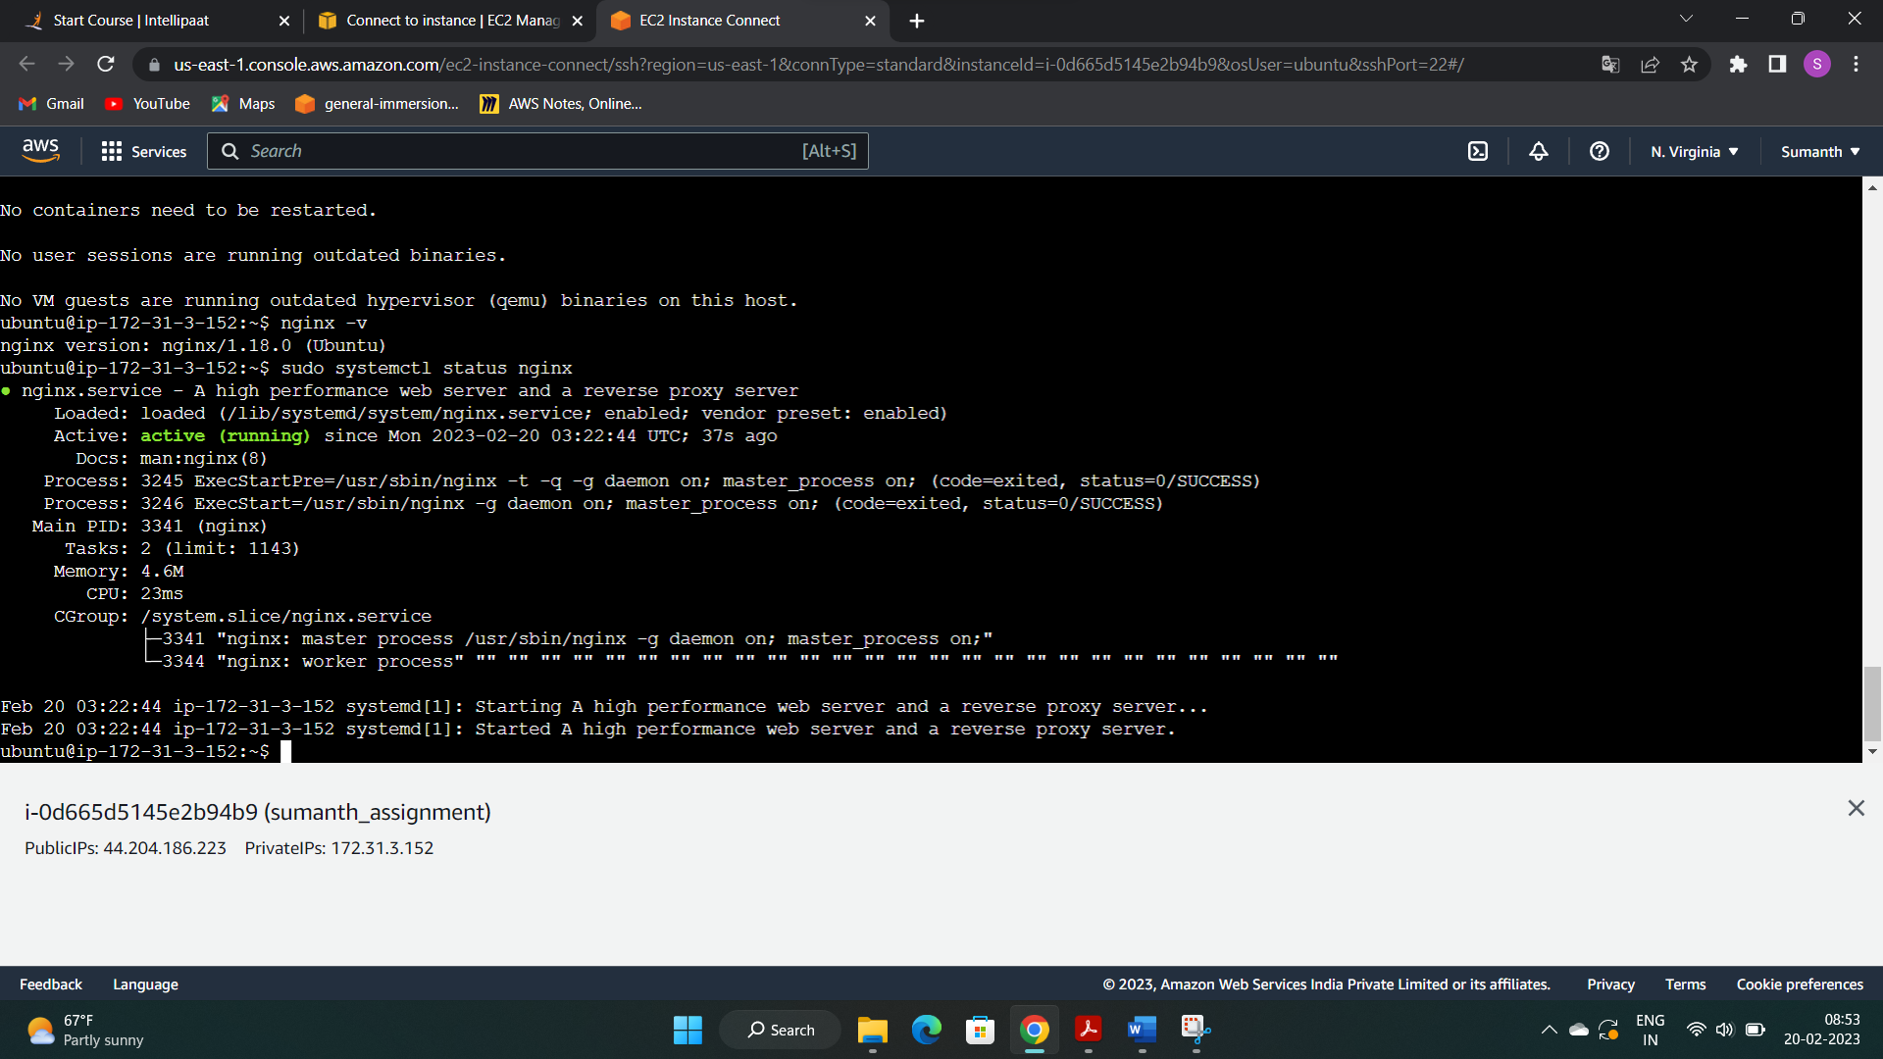

1. **Successfully installed the nginx webserver**

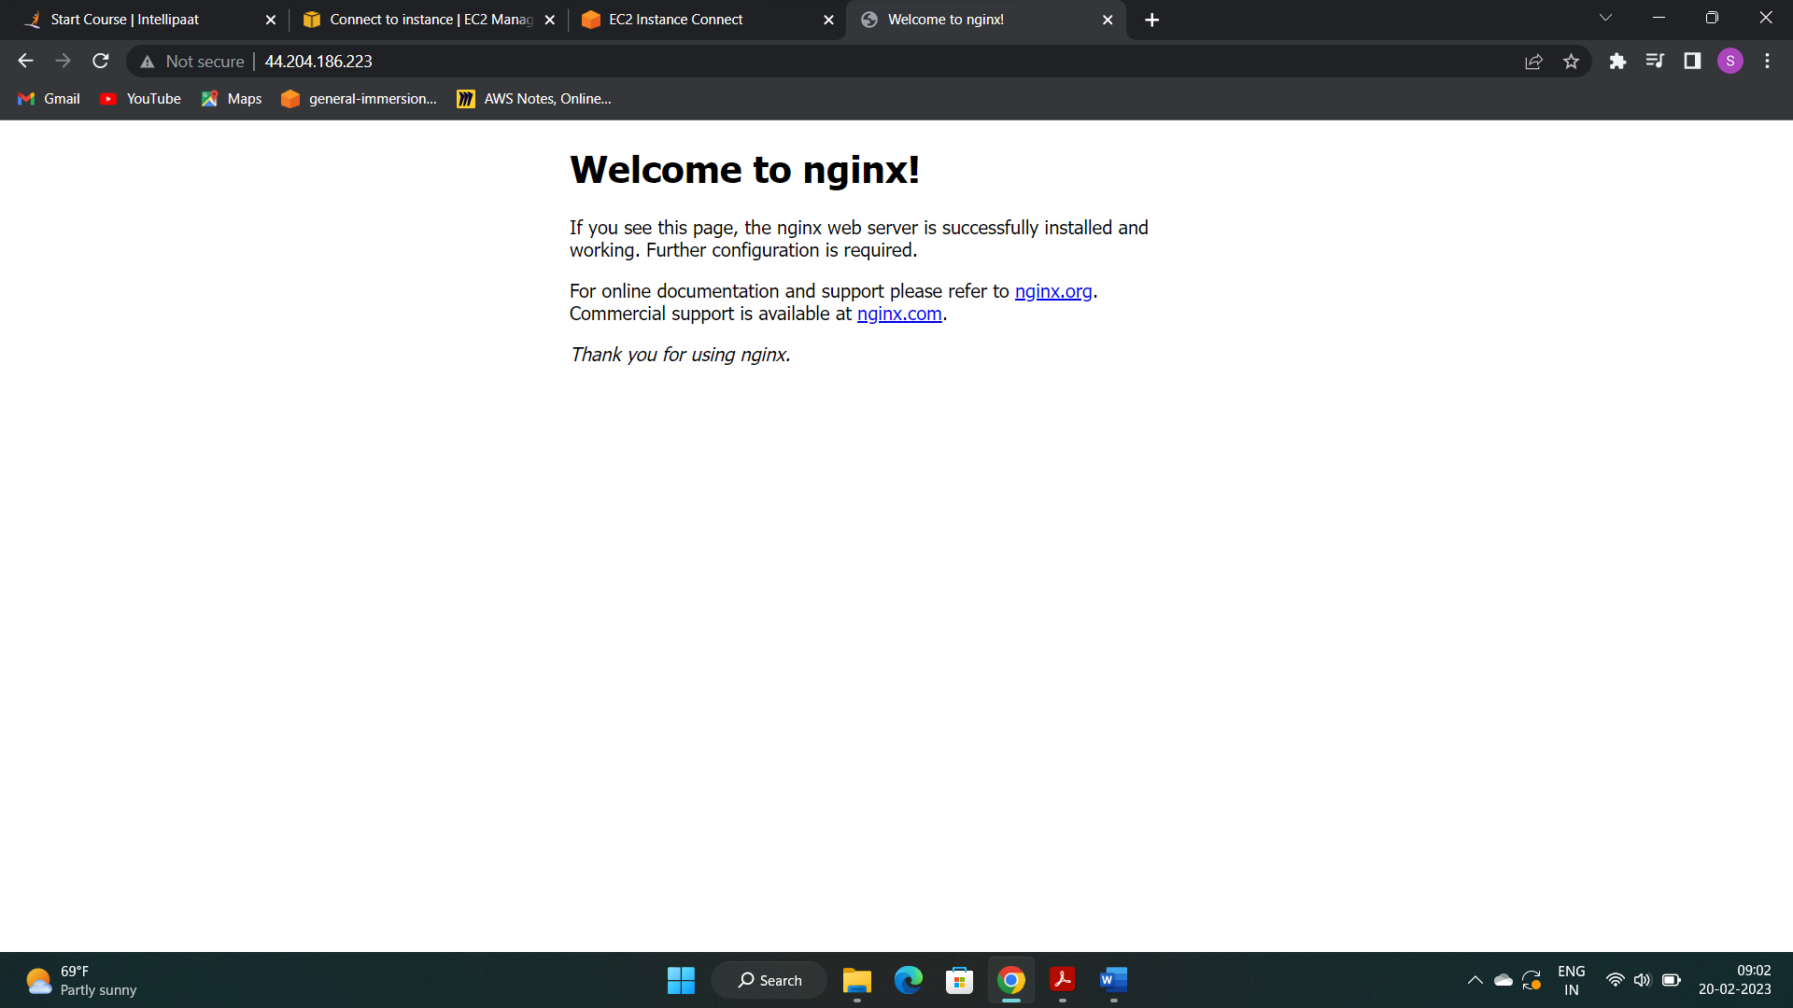

1. **Changed the default website to “hello world” page**

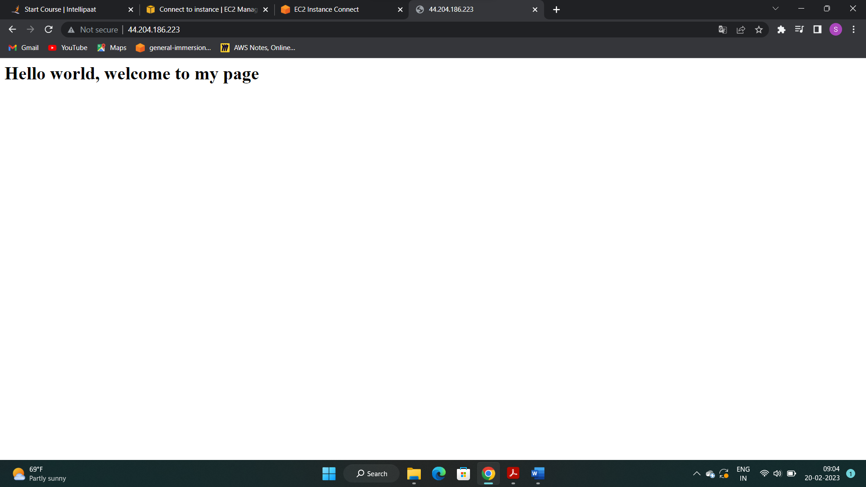

1. **Terminated the instance after completing the assignment**